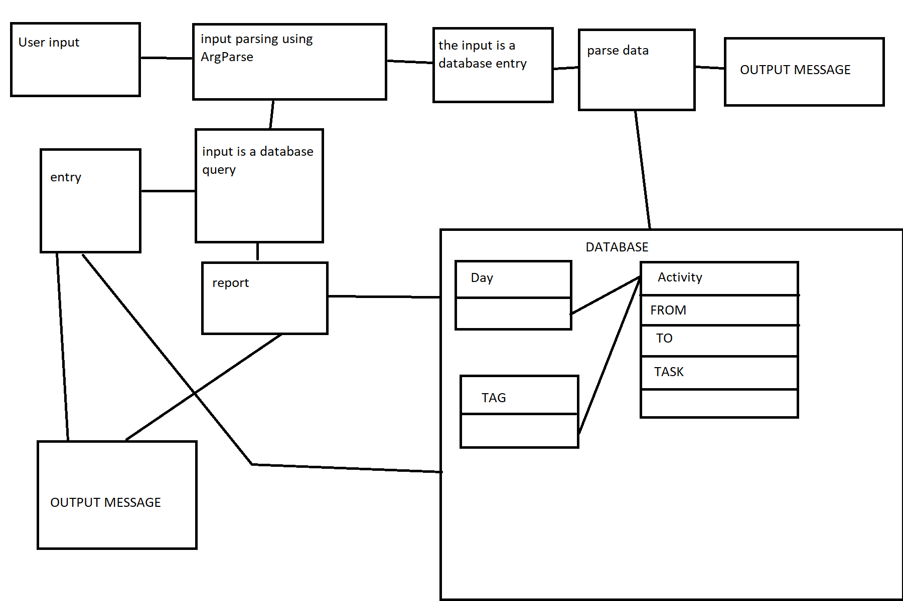
Sketch document
This is what the control flow for the application will look like.
For the database, we use three tables, one for storing the date, one for storing the tags and one for storing the activity.
I used ms paint so it is not reflected in the sketch, but Day and Tag tables have a 1 to many relationship with Activity.
The report and the entry blocks will have their own methods, querying the database and outputting the respective output. Similarly, te parse data block would also parse the input data into an entry in the database.

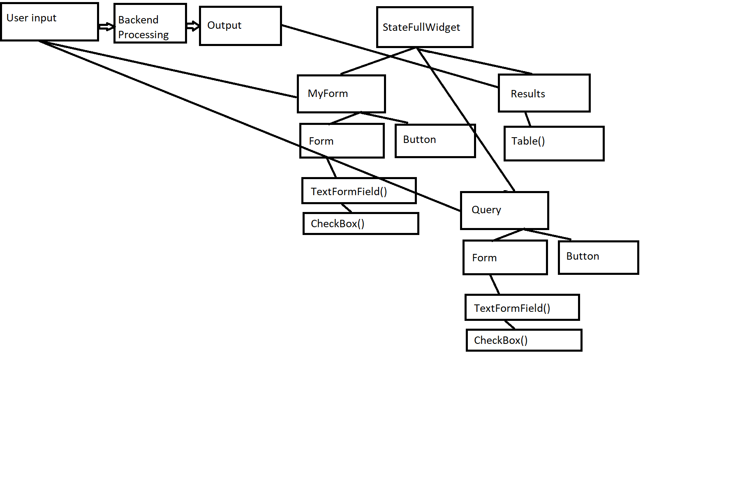
This is what the GUI will sort of look like.
We use flutter Material App as our GUI.
For user input, we have two forms (MyForm and Query)
MyForm has a few components for input and if the user input is valid, it will update the database with an additional query.
Query has a few components for input as will, but query is used to query the database. If the user input is valid, query will redirect the user to the Results page where the form information will be based and the database will be queried to display the information in a table.

